

*EPROJECT*

*ONLINE STATIONARY MANAGEMENT SYSTEM*

|  |  |  |
| --- | --- | --- |
| **Supervisor.** | Miss Warda Jawed | |
| **Batch.** | 2302E2 | |
| **Semester** | HDSE **1** | |
| **Group.** | A | |
| **Serial No.** | Enrollment Number | Student Name |
| 1. | 1458683 | Qurat Ul Ain |
| 2. | 1458357 | Muhammad Taha Shahid |
| 3. | 1458664 | Muneeb Ur Rehman. |
| 4. | 1457819 | Sundus Khalid Khan |
| 5. | 1445155 | Umme Fatima. |

**ACKNOWLEDGEMENT**

Before anything, I would like to thanks my beloved Miss Warda Jawed who helped us a lot in reviewing this project within the limited time frame.

Secondly, we would also like to thank the eProject team at Aptech Head Office, who gave us the golden opportunity to do this wonderful project about Nexus Aquarium

Thirdly, we also thank the eProject team, some of the benefits are as under: Re-enforcement of skills happens in the experiential learning process. A mentor, ensuring that we do not get drifted, constantly guides us. It gives us a lot of confidence to face an interview as we have worked on a project. We can explain virtually everything on the subject.

***SYNOPSIS***

This project is aimed at developing a tool for tracking the Stationery request for an organization

named HMT Technologies. Normally in any institution the request for the stationery is tracked via an

e-mail or via excels sheets or registers and this leads to tremendous wastage of resources. For

example: - there may be scenarios where the quantity kept in the go down or store of the item may

be more than needed and the supply of few items may be less than needed. This system will thus

help in reducing the wastage at the same time look into generating reports to give a high level view

to the higher management for the benefit of the organization.

***PROBLEM STATEMENT***

**Introduction:**

The problem statement is attached separately in a file “Web based stationery management system.doc”

**Standards plan:**

Every code block must have comments.

The logic of the program needs to be explained. Proper documentation should be maintained.

Complete Project Report along with synopsis, code and documentation should be prepared.

**Documentation:**

No project is complete without documentation. In fact, it is one of the most important activities during the development of a project. The documentation of an ideal project will be in the form of a project report comprising of the following

documents:

* Certificate of Completion.
* Table of Contents.
* Problem Definition.
* Customer Requirement Specification.
* Project Plan.
* E-R Diagrams.
* Algorithms.
* GUI Standards Document.
* Interface Design Document.
* Task Sheet.
* Project Review and Monitoring Report.
* Unit Testing Check List.

***SCOPE OF THE WORK (IN BRIEF)***

The website is to be developed for the Windows Platform using ASP.NET CORE. The site should work well in all leading browsers including Chrome, Firefox etc. Our welcome page icon is re-directed to the main web page Ever essential content direct to relative content.

***Screenshots***

**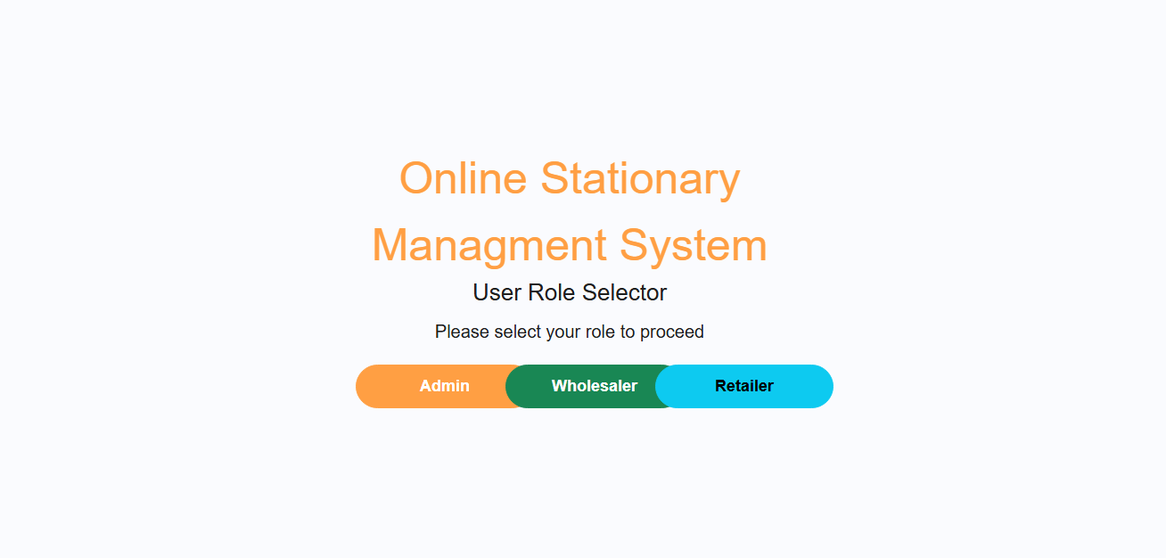*ACCESS PANEL:***

*ADMIN SIGN-IN:*

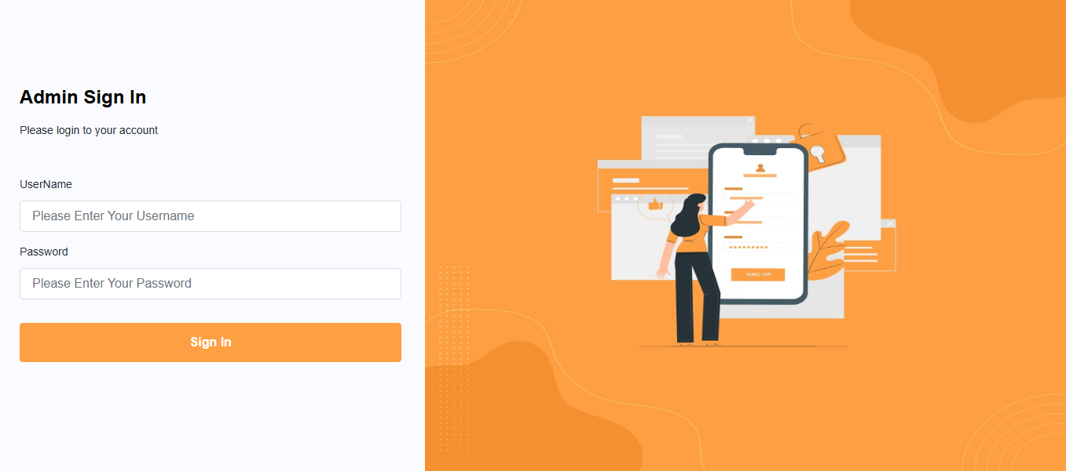

***WHOLESALER SIGN-IN:***

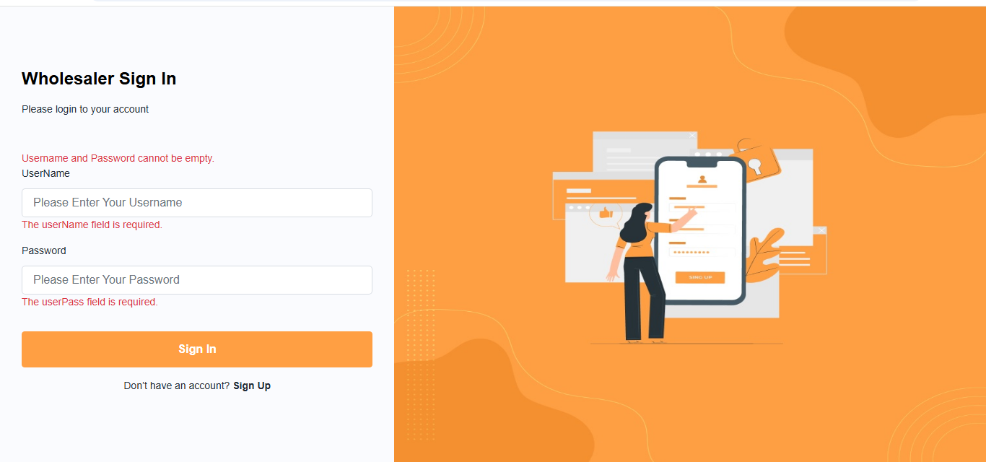

***RETAILER SIGN-IN:***

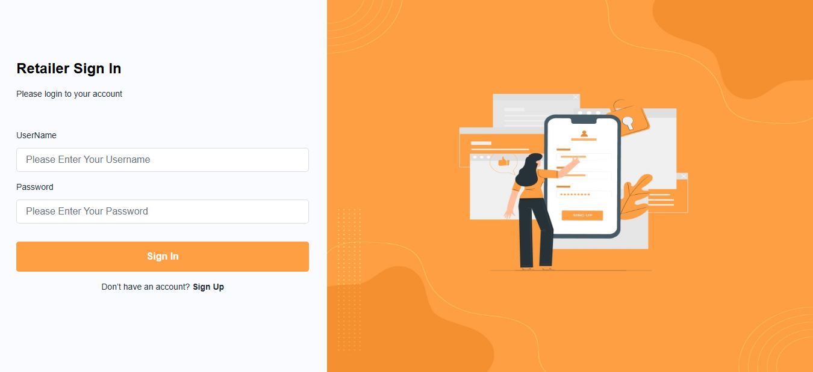

***WHOLESALER SIGN-UP:***

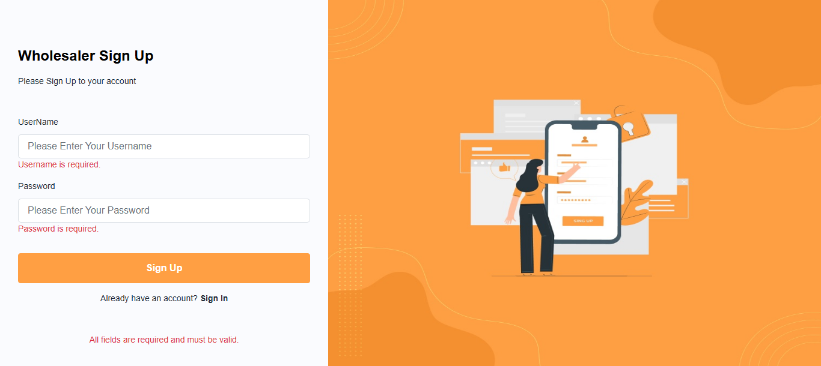

**DASHBOARD(ADMIN):**

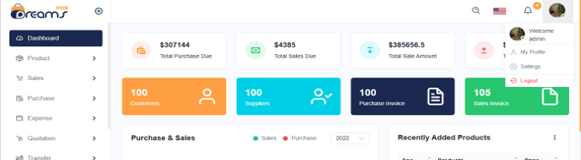

**DASHBOARD(WHOLESALER):**



Product List:

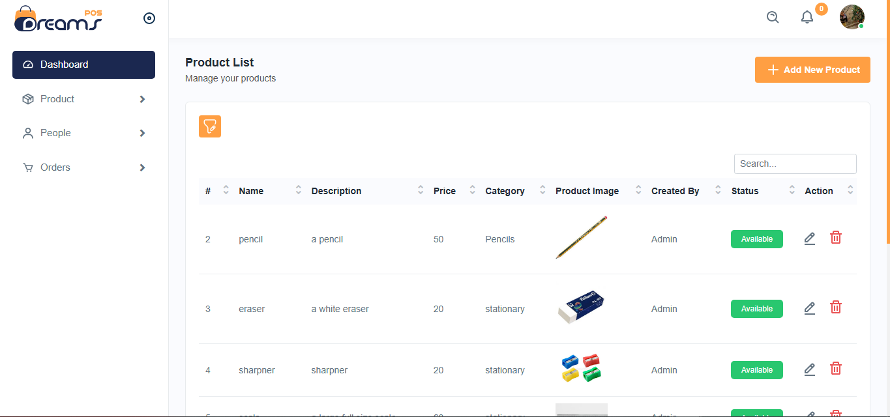

Category List:

Add Category:

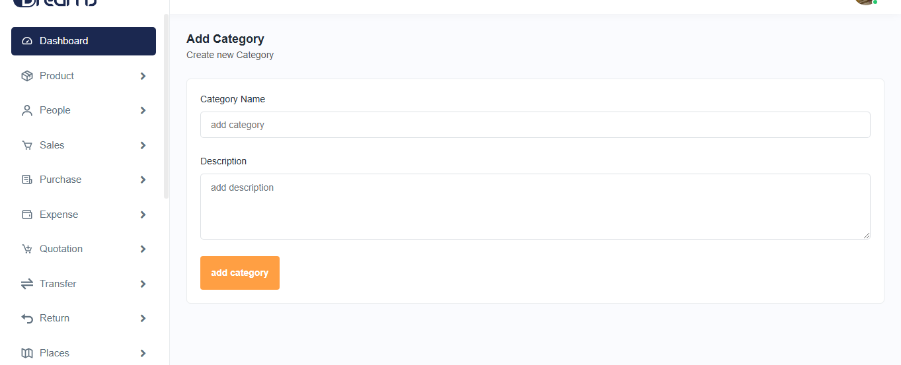

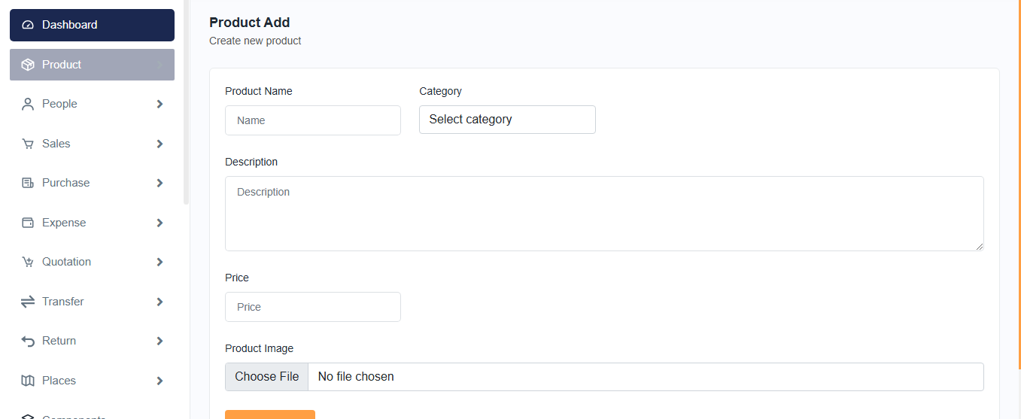Product Add:

Edit Product:

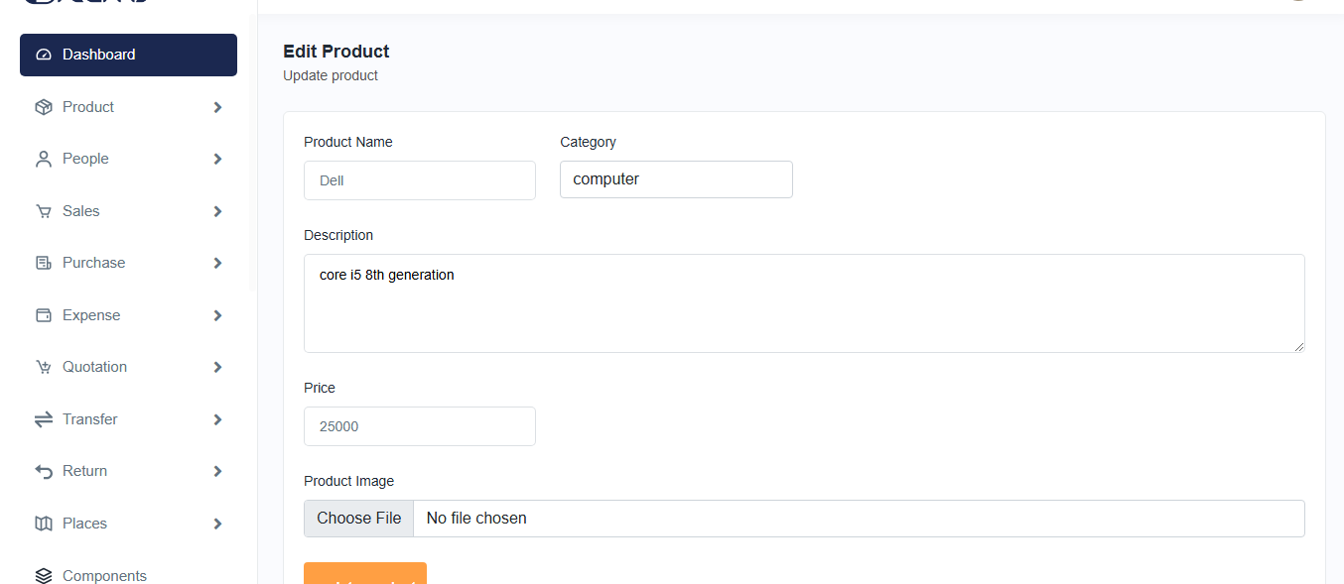

*Edit Category:*

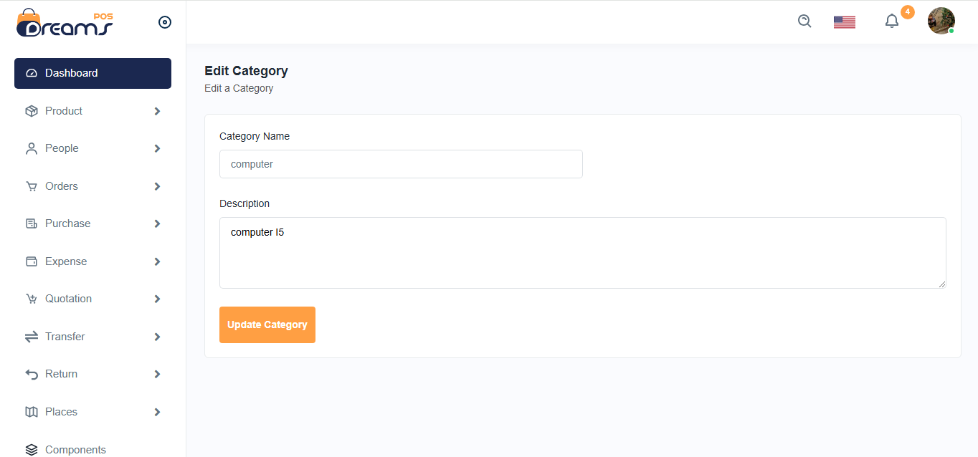

*Wholesaler List:*

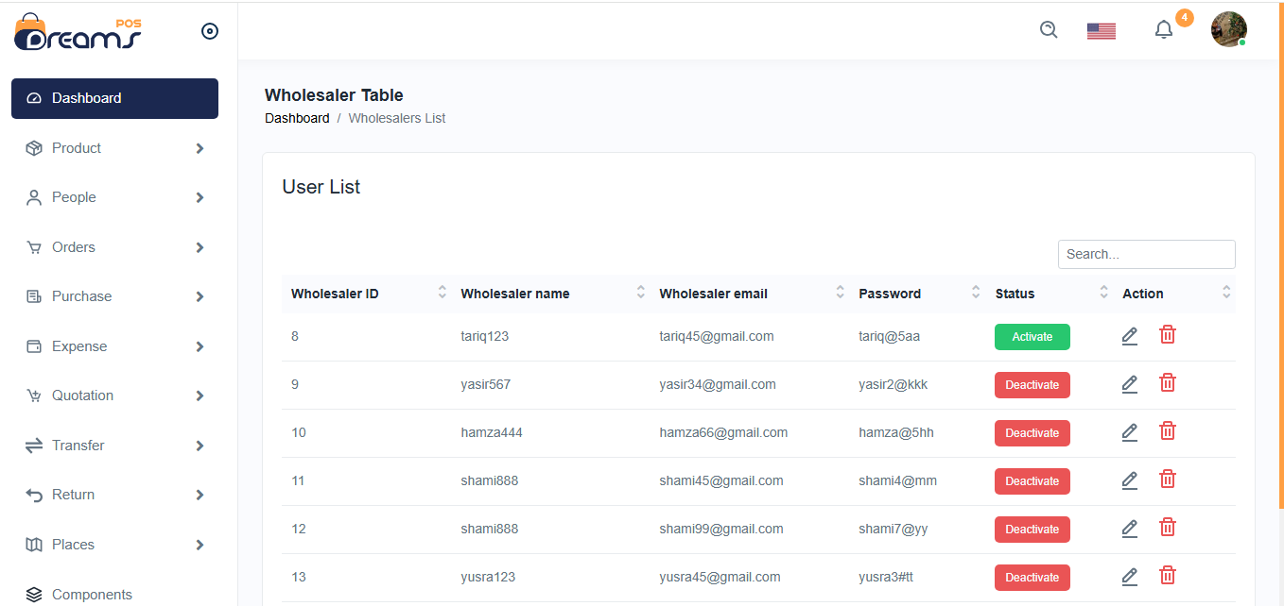

*Product List:*

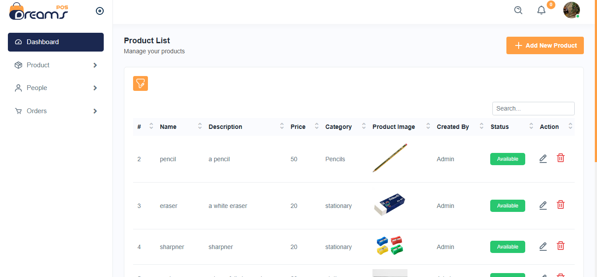

*Wholesaler Purchase List:*

